

SECP1513: TECHNOLOG INFORMATION SYSTEM

**Report and Log Book**

Driving School Registration System

Faculty of Computing

Prepared by: Group 1

* MUHAMMAD SYAFIQ BIN ABD RAZAK SX240659ECJHS04
* MUHAMMAD SYAZWAN BIN KAMARUZAMAN SX240290ECRHS04
* SAEED BIN ABDULRAHMAN SAEED BASALAMA SX230800ECJHS04

**Table Of Content**

|  |  |  |  |  |  |
| --- | --- | --- | --- | --- | --- |
| 1. | Driving School Registrations System Mockup Design Report | | | | 2 |
|  | 1.1 | Introduction | | | 2 |
|  | 1.2 | Problem Statement | | | 3 |
|  | 1.3 | Project Scope | | | 4 |
|  | 1.4 | Design Approach | | | 4 |
|  | 1.5 | Mockup Screen | | | 5 |
|  |  | 1.5.1 | Login Page | | 5 |
|  |  | 1.5.2 | Landing Page & Dashboard | | 6 |
|  |  | 1.5.3 | Student Registration Page | | 6 |
|  |  | 1.5.4 | Student Record Management | | 7 |
|  | 1.6 | Team Collaboration and Discussion | | | 7 |
|  | 1.7 | Presentation Plan | | | 8 |
|  | 1.8 | Expected Outcome | | | 8 |
|  | 1.9 | Reflective (Individual) | | | 9 |
|  |  |  |  |  |  |
| 2. | Logbook | | | | 10 |
|  | 2.1 | Project Information and Background | | | 10 |
|  | 2.2 | Week 1 Activity | | | 10 |
|  | 2.3 | Week 2 Activity | | | 10 |
|  | 2.4 | Week 3 Activity | | | 10 |
|  |  |  |  |  |  |
|  |  |  |  |  |  |
|  |  |  |  |  |  |
|  |  |  |  |  |  |
|  |  |  |  |  |  |

1. **Driving school registration system mockup design report**
   1. **Introduction**

In today’s digital era, many business are transitioning from manual solution to digital systems to enhance flow efficiency. Involve a client planning to open a driving school. Currently, the client have heavily on physical document to manage student registration data, which process challenge such as losing data, disorganization and limited accessibility. To address this issue, a digital registration system is proposed. This system is aim to keep the student registration track record and improve overall management through a user friendly interfaces.  
  
Objective:  
The objective of this project is to design a mockup of the registration system using photoshop. This mockup will serve as a visual to represent the system’s structure, layout, and features. By presenting the system mockup, the client can visualize the final outcome and provide feedback after the development phase finish. This step is to make sure that the final outcome of the system will align with the client’s requirements and expectations.

* 1. **Problem Statement and Design Thinking**

**Problem Statement**:

The driving school currently faces several operation to rely on physical data management . the issue include:

* Data loss risk:
  + Physical document can be misplace and damage
* Inefficiency:
  + Manual searching and organize registration record is time consuming.
  + Manual data entry and record getting increase human error.
* Limited accessibility:
  + Physical record restrict access to authorized personal only when on site.

**Design Thinking Phase:**

* **Purpose of mockup:**

Mockup serve as a crucial step in addressing the challenge. Mockup act as a blueprint for the future digital system by offering a visual guide to system features and user interface design. By showing the mockup, the client can getting better understanding the system flow and usability by ensuring all the point are given.

* 1. **Project Scope**

**Mockup Goal:**

The primary goal of the mockup is to present an organized and professional interface that reflect the system’s functionality. This includes:

* Student Registration
  + To make an easy data entry and record process with less human error and more efficient.
* Dashboard Overview
  + Provide a simple view of registered student.
* Student record management
  + Enable efficient record search, update, and delete of the record.

**Target users:**

The system are design to be used by multiple stakeholders, including:

* Admin staff
  + Responsible for registration of students and managing records.
* Management
  + Overview overall operations and generating performance report.
  1. **Design Approach**

**Tools:**

The mockup is develop using Adobe Photoshop, a powerful tool to create design. Photoshop is allow to control over visual elements to make sure the final mockup accurately represent the client vision system.

UiUx:

The design prioritizes the user experience, and the considerations include:

* Responsive Design
  + To make sure the system can be access from various device, including desktop, tablet and smartphone.
* Navigation
  + Simplify the user journey through logical page layout and clear labels.
* Visual Consistency
  + Maintaining a cohesive design language across all pages to enhance usability.
  1. **Mockup Screens**

The following sections show the primary screens of the registrations system mockup. Each screen reflects a specific functionality for the system operation.

* + 1. **Login Page**

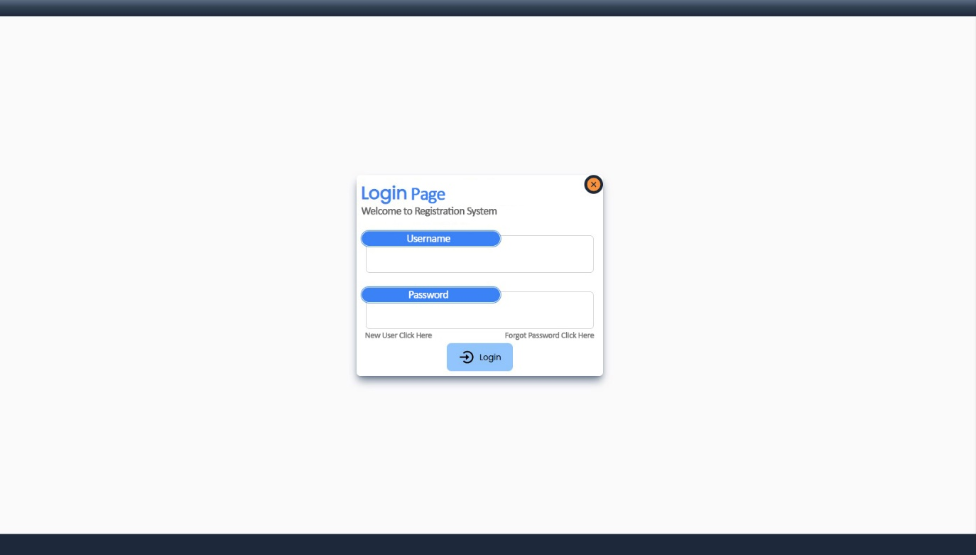

* Login page is the entry point to access the system by entering the username and password as well as option for password recovery and new user registration. Login page is designed to make sure security to easy access. The layout will feature a clean and responsive design for all device.
  + 1. Landing Page & Dashboard

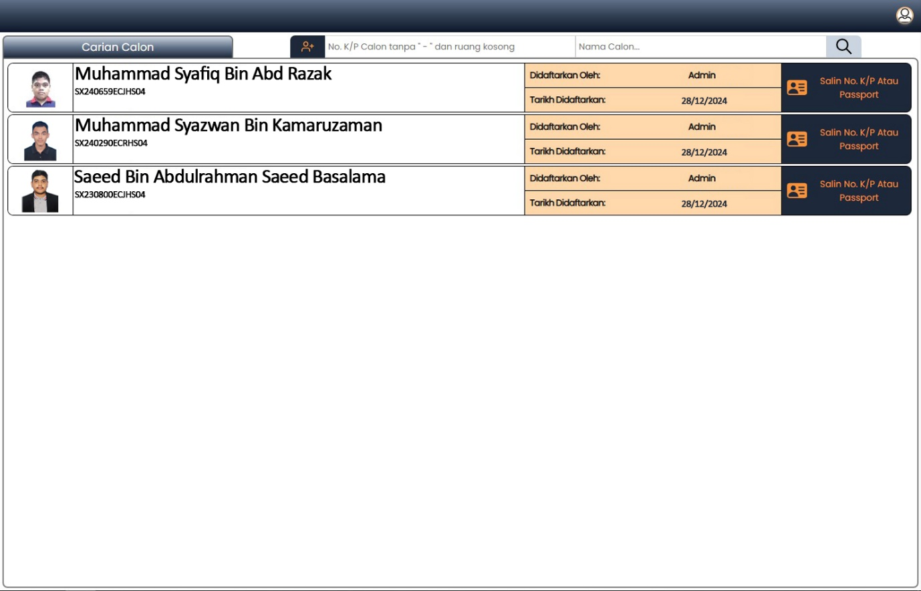

* Act as central hub by displaying real time data on student registration, system notification, and upcoming appointments feature.
  + 1. Student Registration page

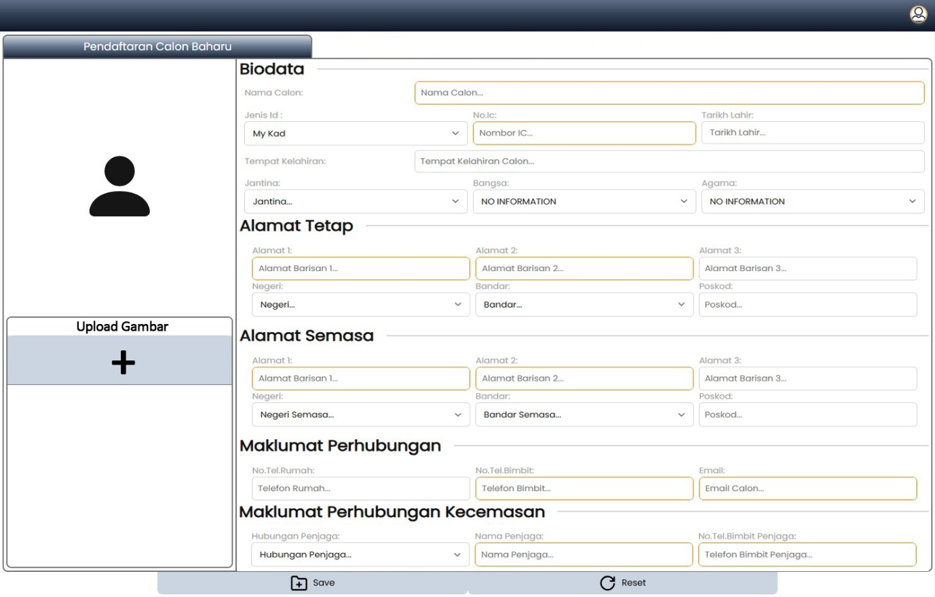

* This page is to admin key in the student data by capturing details such as personal information.
  + 1. **Student Record Management**

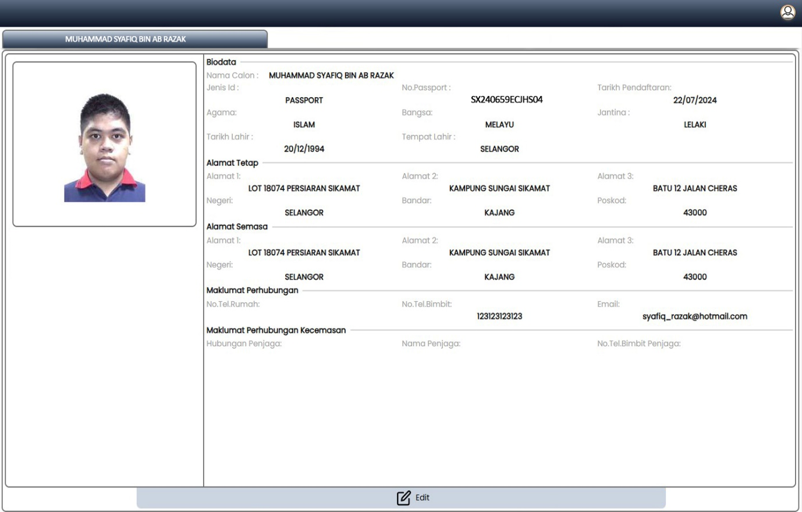

* This screen is allow admin to edit current student records
  1. **Team Collaboration and Discussion**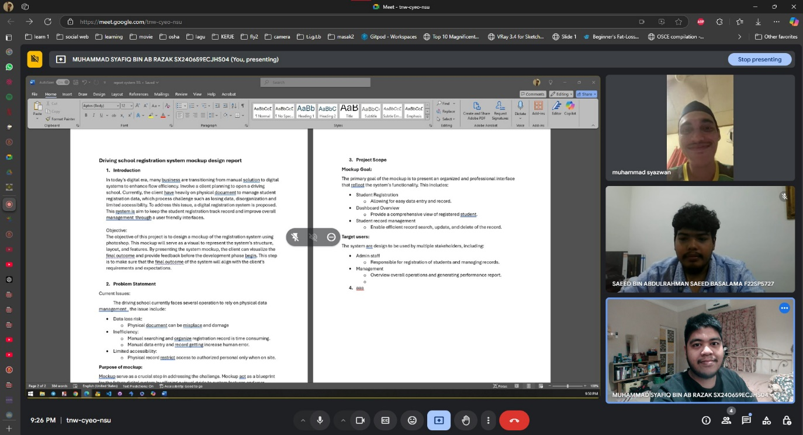
* This picture capture discussion sessions, design ideas, and feedback from client exchange during meetings. It serve as documentation of the collaborative process behind the mockup design.
  1. **Presentation Plan**

**Client Review:**

By completing the mockup, it will be presented to the client in a formal review session, and during the presentation, each screen will be explain in detail by highlighting key features and functionalities. The client feedback will be make sure that all the expectations are meet before proceed to the development stage.

* 1. **Expected Outcome**

**Results:**

The mockup design will be show a clear path for the development team, and will make more clearer and align the final outcome with the client vision. Additionally, the mockup serves as a tool to identify early potential design flaw and make sure smoother transition to the coding phase. By digitalizing the registration process, the driving school will be benefit to the organization from enhancing operation efficiency, improve data entry accuracy, and greater accessibility to student records. The propose system is expected to significantly reduce admin workload and create more experience for both staff and student.

* 1. **Reflections**
* **Muhammad Syafiq Bin Abd Razak: Project lead/ UiUx Designer**
  + **Personal Goal in this industry:**
    - By getting to conquer all skill by just not being fullstack developer, but can conquer to be cyber security as well.
  + **Personal Impact of design thinking:**
    - By getting improve skill in problem solving and design thinking based on client needs. By learning this, it will helps a lot to facing the real world situation.
  + **Personal plan to improve potential in the industry:**
    - Will learning more about new technologies that have been created every single day and will generating new idea and system using new technology.
* **Saeed Bin Abdulrahman Saeed Basalama: Research and Documentation**
  + **Personal Goal in this industry:**
    - To understand computer science more and use it more efficiently.
  + **Personal Impact of design thinking:**
    - It has allowed me to explore various methods and software which increased my computer literacy.
  + **Personal plan to improve potential in the industry:**
    - Work on more project to build a more concise and appealing portfolio as that's what the industry deems important
* **Muhammad Syazwan Bin Kamaruzaman: Video and Presentation Startup**
  + **Personal Goal in this industry:**
    - To be more knowledgeable about technology information system.
  + **Personal Impact of design thinking:**
    - Learn how to communicate with clients and discussion with teammates.
  + **Personal plan to improve potential in the industry:**
    - Be respectful and responsible when working in the Industry.

1. **Driving School Registration System Mockup Project Log Book**
   1. **Project Information and background.**

**Project Title: Driving School Registration System Mockup Design**

Project Duration:

Start Date: 07/12/2024

End Date: 28/12/2024

* 1. **Week 1: Project Startup**

Date: 07/12/2024 – 13/12/2024

Activities:

* Starting with Initiate potential client by having a meeting to discuss project requirement.
* Identified client challenges in current manual registration system process.
* Define project scope and objective.
* Assigned role to team member.
* Client emphasize to focus on simple user interfaces.
  1. **Week 2: Research system design and flow**

Date: 14/12/2024 – 20/12/2024

Activities:

* Do some research by searching for design trends for registration systems.
* Create some prototype design for the landing page and dashboard.
* Create some prototype design for the registration pages.
* Having meetings with team members for review design sessions.
* Begin drafting project report structure.
  1. **Week 3: Mockup Development**

Date: 21/12/2024 – 28/12/2024

Activities:

* Developed mockup screen for login, landing, registration, and student record management pages.
* Having meetings with client by showing the final design mockup.
* We Gathered feedback from client and made an adjustments to the mockup design.
* By using the client feedback, the team member prepared the final presentation slides and project video.
* Video of the activities is recorded to showcase of the system mockup, and client feedback.
* Finalize report and submit by project deadline.